COSC 364
Internet Technologies and Engineering
Assignment 1 – RIP Protocol

Michael Jensen – mto59 - 36622258
David Barclay – dlb70 – 18505639

Assignment Contribution:
Contribution to the assignment was an even 50%/50%

Good parts:
Program structure; Well defined classes with encapsulation of responsibility for specific functions. This makes it more object oriented and easier to maintain and navigate in the code. Though it makes the code a bit longer.
Commenting; Functions and methods are described with a comment defining the purpose of the method.
The way that the timing is handled allows for operations to happen out of order so that no operations (update sending, processing, garbage collection) have to wait for a long time. The program does not need to loop sequentially or use a counter to trigger operations, instead, they all rely on individual timers to trigger, meaning that timing is accurate and routers do not converge their timers.

What could be improved:
Could add checks on messages to confirm that the contents are in the correct order and have the correct values.

Atomicity of event processing: All events occur in sequence completely.
Using the select() statement, we read in available updates and process them all sequentially (not necessarily in the order they arrived). If an update is corrupt, we drop it, meaning that we do not partially update.
By using the select() statement, we do not interrupt any other operations, and we wait for packets to be read. This ensures that all other operations finish completely before update processing occurs.

Testing: Create scenarios with predictable behaviour then test actual behaviour.
A test could be added to demonstrate split-horizon with poisoned-reverse, but doing so would be very difficult, as it would be necessary to align the timers and updates of separate processes.
Tests should show that the routers converge correctly.
Test should show that the routers detect failures and recover correctly.
Tests should show that the routers reconverge correctly after revival.

Commit 521ebb3
Test 0: Assignment.

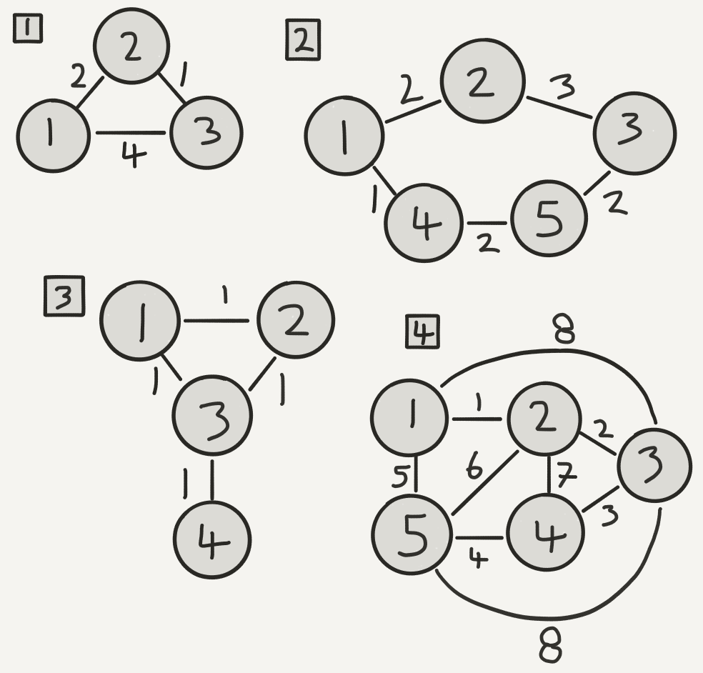
Test Case network graphs.

Test 1: Trivial 3 node network. Test is designed for testing basic functionality.
Test 2: Equal cost path.
This test case is designed to show that routes are not chosen in preference to minimizing hops. It is assumed that routers are initialized in increasing numerical order, so that results are consistent. Routers are first allowed to converge, then router 2 is killed temporarily to force routers 1 and 3 to route through 4 and 5 to reach each other. After routers converge while 2 is dead, revive router 2. No subsequent change should be observed as the metrics of routes 1-2-3 and 1-4-5-3 are both equal, and the protocol does not prefer minimum hop routing, only minimum cost. (note that other routes of equal distance may be inconsistent.)

Test 3: Split Horizon with Poisoned Reverse demonstration.
This configuration is designed to test the robustness of the Split Horizon with Poisoned Reverse. Routers are first allowed to converge, then router 3 is killed. If routers 1 and 2 detect the failure at the same time, and have both recently received a periodic update from each other, then they may set their route to 4 through each other. With poisoned reverse, in the next update received by each router, the routers will simply set the metric to router 4 to infinity. Without poisoned reverse, the route to 4 will persist until it times out as the routers do not report it to each other.
This test is very hard to reproduce as it relies on timers being synchronised.

Test 4: (Almost) Fully connected network (5 nodes)
This test case is almost trivial, but is designed to test the robustness of the protocol with a highly connected network.

